

IriShield MDS Package

**Document Version 1.0.0**

USER’S MANUAL

**Document Change Record**

This page records any updates and revisions made to the IriShield MDS Package User’s Manual.

|  |  |  |  |
| --- | --- | --- | --- |
| Doc ver. | Date | Change Description | Software ver. |
| 1.0.0 | 19th May 2021 |  | 1.4.0 |
|  |  |  |  |
|  |  |  |  |
|  |  |  |  |
|  |  |  |  |
|  |  |  |  |

**Notice**

The information contained herein is provided solely for the purpose of assisting customers to understand how to operate and integrate IriTech’s hardware and software and is not to be released, reproduced, or used for any other purpose without written permission of IriTech, Inc.

IriTech reserves the right to make changes on this hardware and software with the intent to improve its functionalities. Information and specifications contained in this document are subject to change without prior notice and do not represent a commitment on part of IriTech.

Copyright © 2021 IriTech, Inc. All rights reserved.

**Table of Contents**

1. Introduction 4

1.1. IriShield MDS Package Overview 4

1.2. Organization of the Manual 4

2. Software Installation 5

2.1. System Requirements 5

2.2. IriShield MDS Package Installation 6

2.3. Confirm the installation process 10

2.4. Uninstallation 12

3. Getting Started 14

3.1. Server Information 14

4. Initialization, check if device already initialized 15

4.1. Initialize device 15

4.2. Restart when service stopped 16

4.3. Set and Get Environment 17

4.4. Management Service Settings 18

4.5. Customer Services 20

5. Software updating 21

5.1. Update period 21

5.2. Update process 21

6. Troubleshooting and FAQ 21

6.1. Windows does not recognize the device 21

6.2. Device Busy message 21

6.3. Server communication error 22

6.4. Error Invalid serial number 22

# Introduction

## IriShield MDS Package Overview

IriShield MDS Package is the software package which is released for supporting MOSIP Device Specification. There are 2 software applications in the package, the IriShield MDS Service and the IriShield Client Management Service software. These 2 software applications are the windows service which will manage the capture and sign processes, register and upgrade devices…

IriShield Client Management Service will implement an *“init”* method internally to check if device is  
registered, connect to management server, initialize and rotate keys, and check for  
software upgrades. When running, management client will detect for physical device connected and  
readiness of it. There is a GUI for user to input credential, get the information of devices, servers, and do the *“init”* process manually.

The IriShield MDS Service will do the capture process and update the information to server.

## Organization of the Manual

The purpose of this manual is to provide complete information about IriShield MDS Package. It includes an overview of the whole IriShield MDS Package, its functionalities and useful tips on how to use IriShield MDS Package. The rest of this document are organized as follows:

* Software Installation
* Getting Started
* Initialize device, check device ready (initialized), restart when services stopped
* Supports
* Troubleshooting and FAQ

# Software Installation

## System Requirements

The requirements for a Host PC to use IriShield MDS Package with IriShieldTM camera are as follows:

* Windows 7, Windows 8, or Windows 10
* 1GHz Processor or higher
* 1GB RAM or higher
* 30 MB available Hard Disk space
* 1 USB 2.0 port

## IriShield MDS Package Installation

* Run *“Setup.exe”* file in the IriShield MDS Package software package, then click *“Next”* button on *“Setup Wizard”* window to proceed.

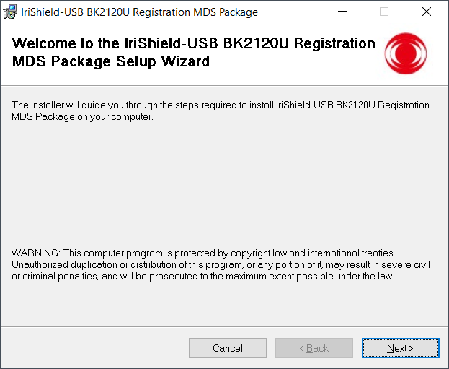

* Click *“Browse…”* button to select the installation folder, otherwise IriShield MDS Package will be automatically installed into the default folder (*“C:\Program Files (x86)\IriTech\IriShield-USB BK2120U Registration MDS Package\”).* Then, click *“Next”* button to continue. Click *“Next”* button to confirm the installation.

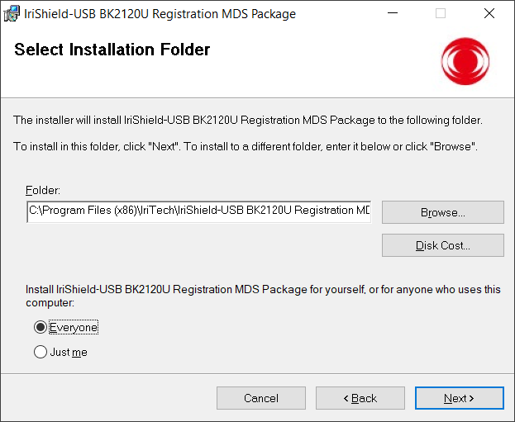

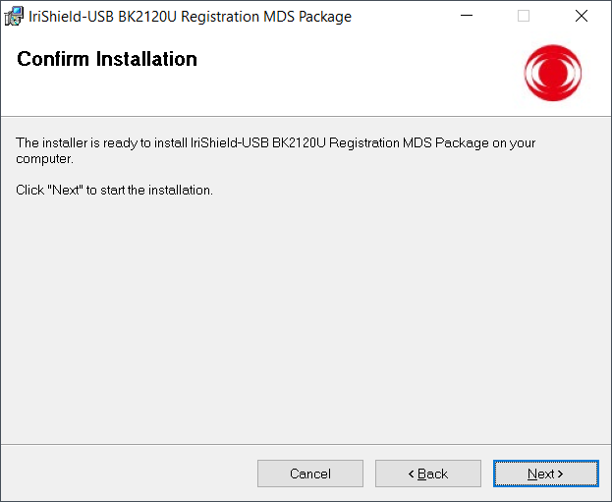

* Put a check on *“I Agree”* button to accept License Agreement and then click *“Next”* button to continue. Wait for the installation process in a while. After the IriShield MDS Package being installed, the IriShield driver installation will automatically start.

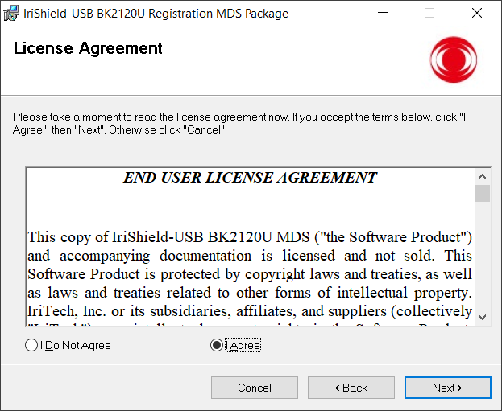

* When the IriShield MDS Package Installation is going to finish, the IriShield’s Driver installation wizard will automatically start. Click “*next*” to continue. After that, put a check on *“I Agree”* button to accept License Agreement and then click *“Next”* button to continue.

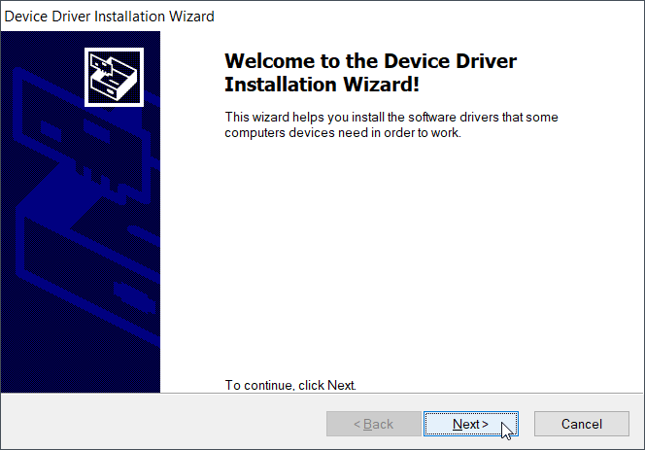

* To install the drive, the admin privilege is required.

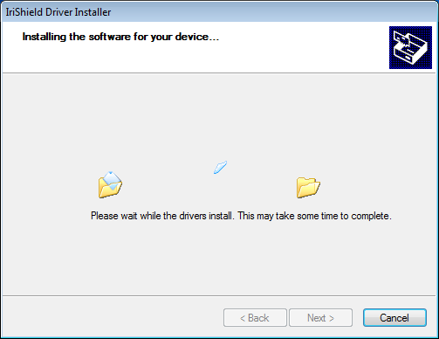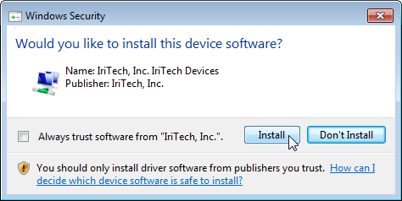

* When the driver installation was finished, a window will occur to inform you. Click *“Finish”* to finish IriShiled Drive installation.

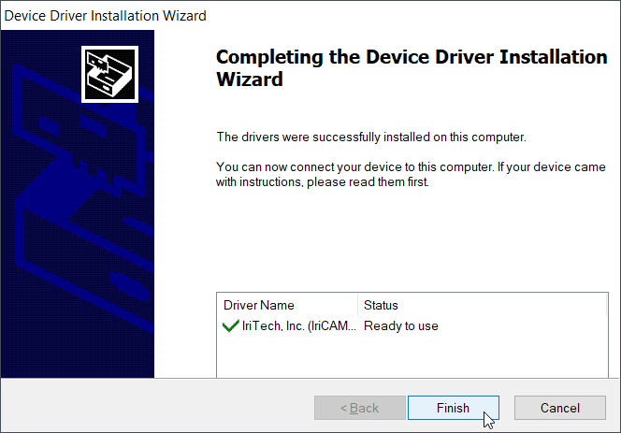

* After the IriShield Driver installation was finished, Management Service Setting will display.

Please select the Device registration environment default as P (Production). Please set Device registration environment default as D for testing. It is required to input:

* Distributor name: name of distributor where you buy IriShield.
* End customer name: your name

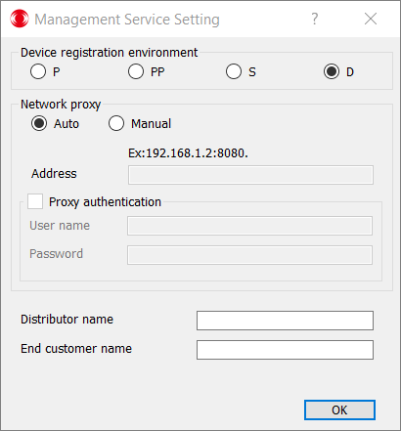

If you are not using network proxy, set the network proxy configuration as default. If you use network proxy, input the proxy configuration.

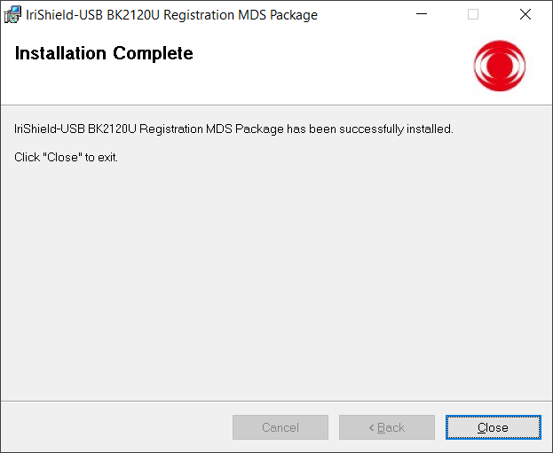

## Confirm the installation process

* The IriShield client management program will now be available at the start menu.

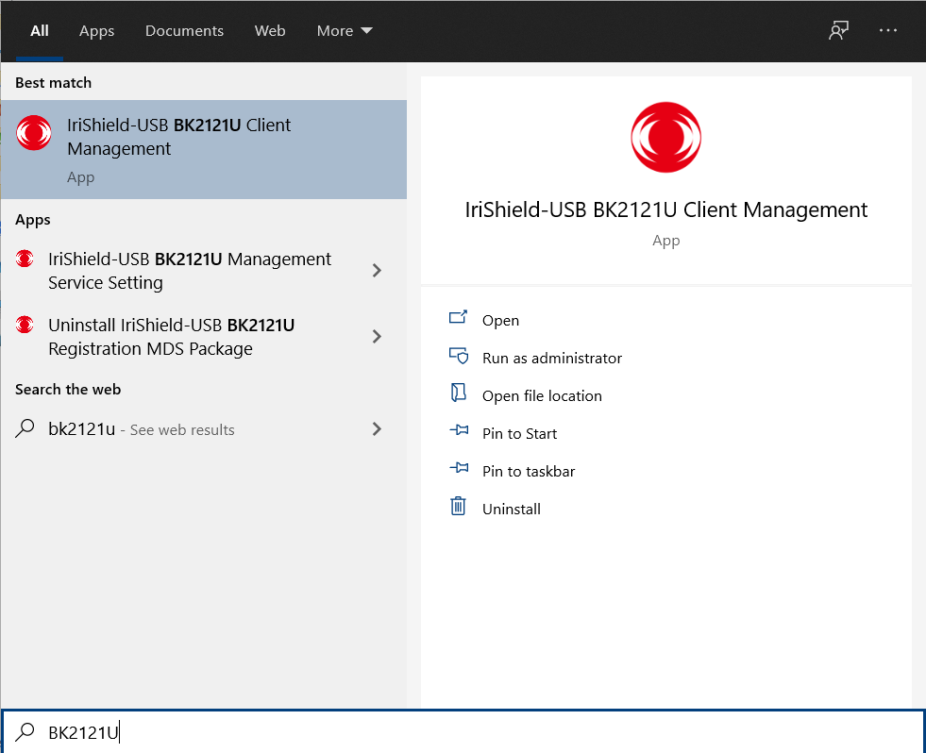

* To check if the driver was installed successfully, connect IriShieldTM device to the PC via USB cable, then right click on the shortcut of *“Computer”* 🡪 *“Manage”* to access *“Computer Management”*.

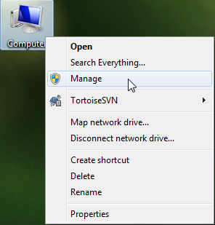

* In *“Computer Management”* window, click on Device Manager, if the installation is successful, user can now see *“IriShield”* driver under IriTech Devices.

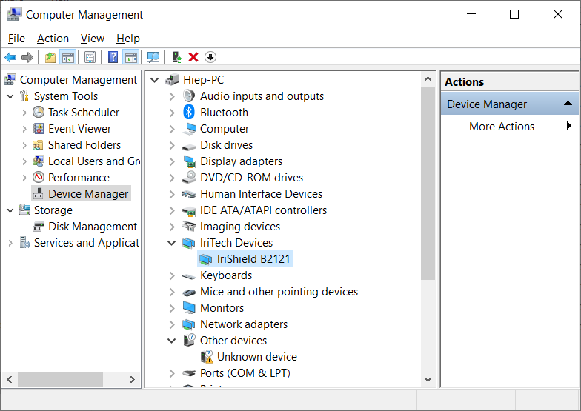

## Uninstallation

There are two methods to uninstall the IriShield MDS Package:

* Select: *Start 🡪 Uninstall IriShield-USB MDS Package* to remove this application.

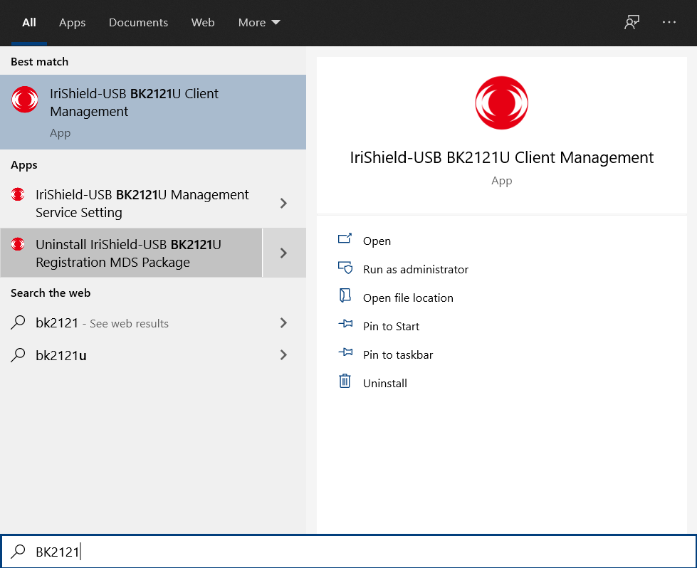

* Go to “*Control Panel” 🡪 “Uninstall a program”* then select IriShield MDS Package application to remove, and follow computer’s instructions to complete the removal.

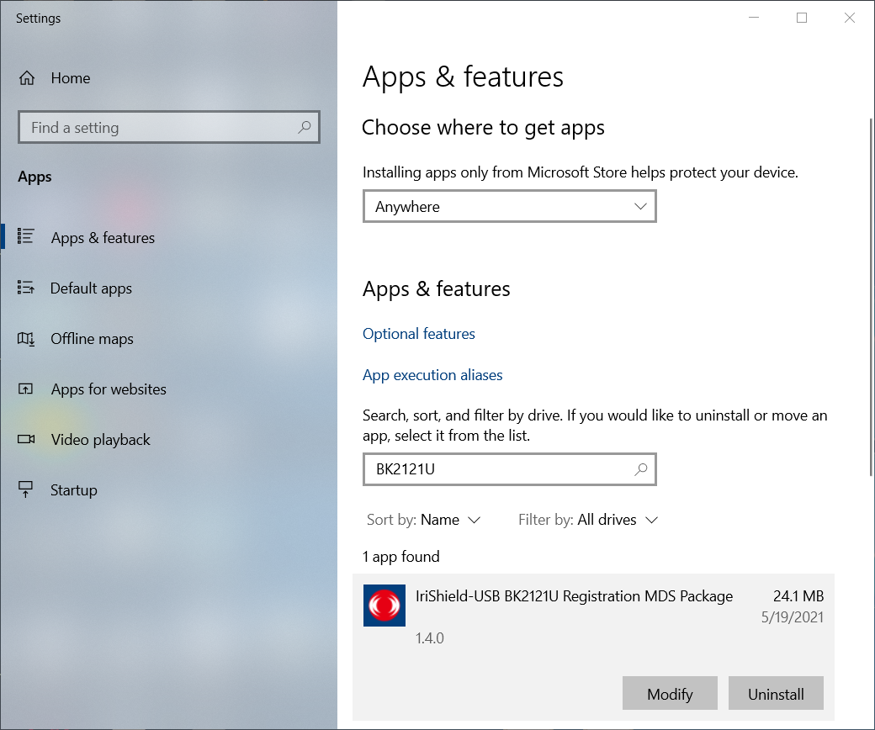

# Getting Started

## Server Information

* After IriShield MDS Package has been successfully installed, there will be a new Program Group called “IriShield-USB BK2121U Client Management” in the Windows Start-Program menu. Run Management Client program to start the Register Device Service Interface.

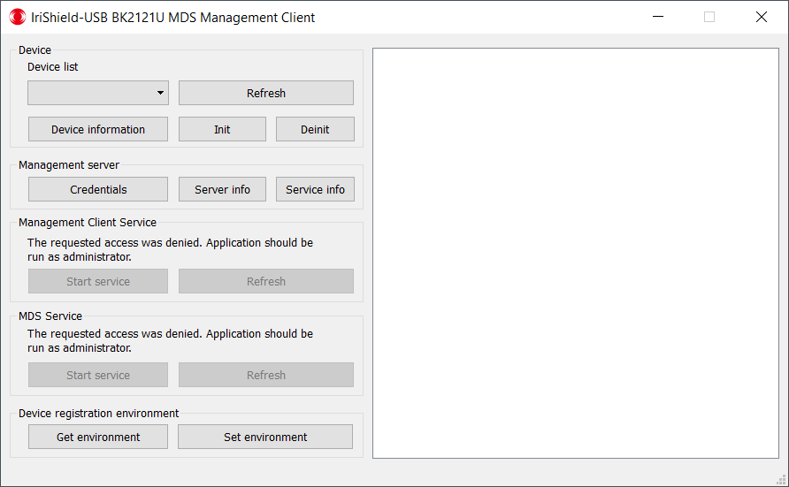

* The Server information button can be used to verify the correction of license file:

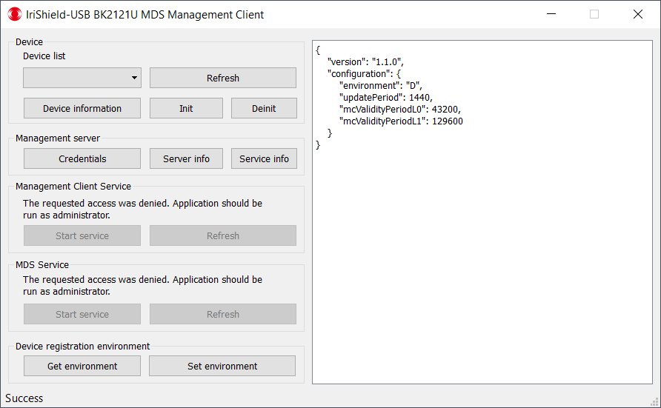

# Initialization, check if device already initialized

## Initialize device

* To initialize the device, firstly, in the IriShield Management Client windows, click *“Refresh”* button to get the current plugged device list.

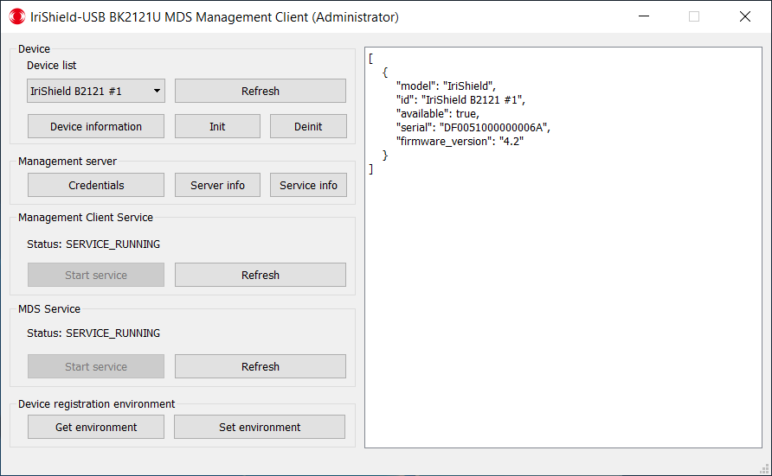

* Then, choose the device that you would like to initialize in the device list, in above image “IriShield B2121 #1”.
* To check if device was initialized, click on “Device information” button, the initialized device will have the information fields: *“mc”*, *“P cert”*, *“PP cert”*, *“S cert”*

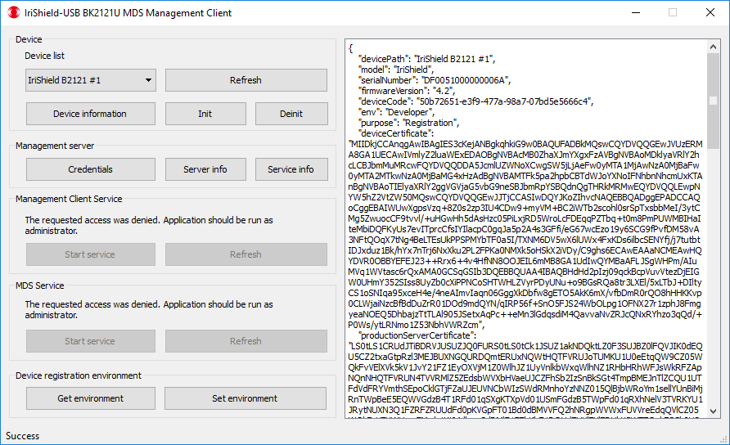

* To initialize IriShield device for MDS, click on “Init” button. If the initializing successfully, message “Success” will show. If there is error, please check troubleshoot at the end of this document.

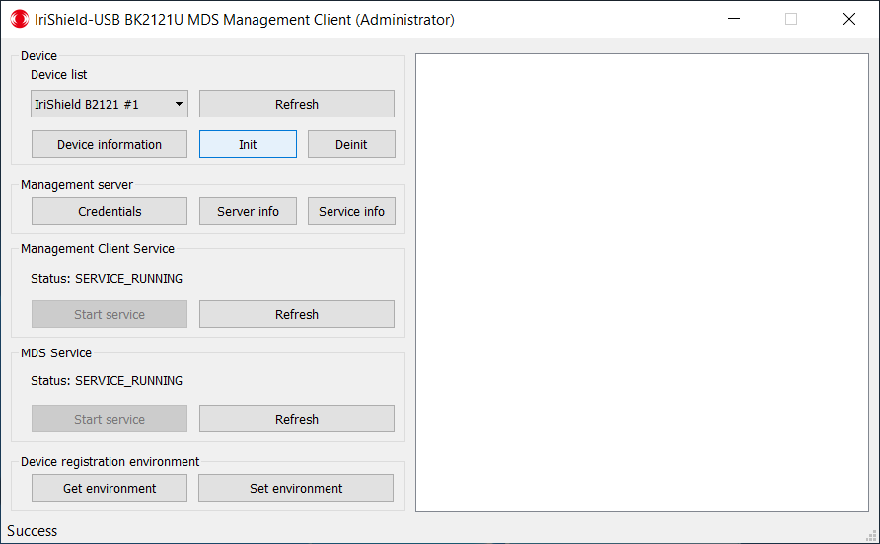

## Restart when service stopped

* For some reason, the IriShield Client Management Service and IriShield MDS service could be stopped. In this case, when we get device information or initialize, a notify will occur at the bottom left of windows, as below:

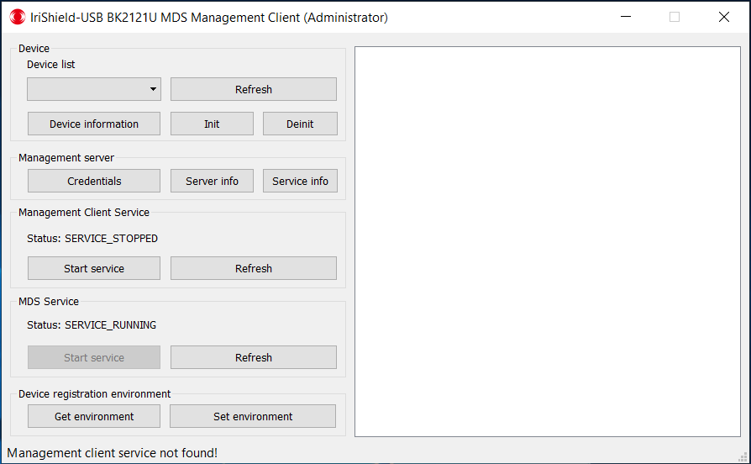

* To restart the service, firstly, reopen the IriShield Management Client windows with admin privilege.

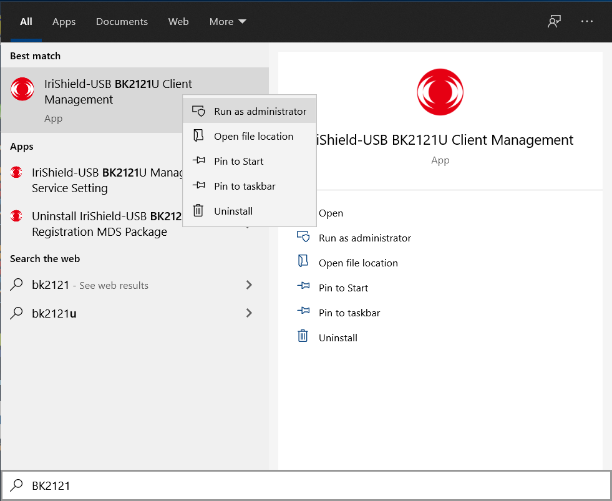

* The windows will occur as below, then click *“Refresh”* to get the status of service
* In case the service status was SERVICE_STOPPED, click *“Start service”* to restart that service

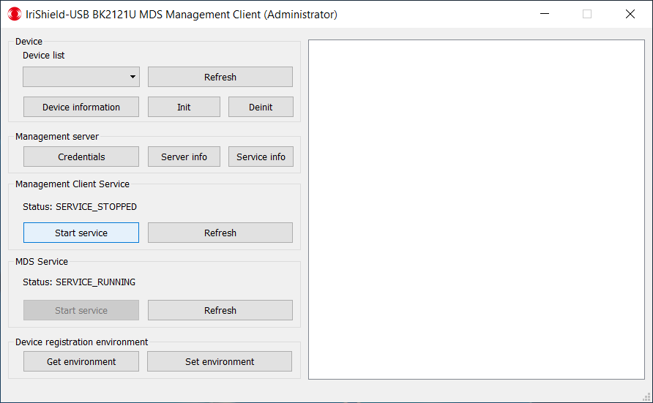

## Set and Get Environment

As default, RD service will work with production server (P). Device registration environment provides a way to change the environment which is used for developer testing only.

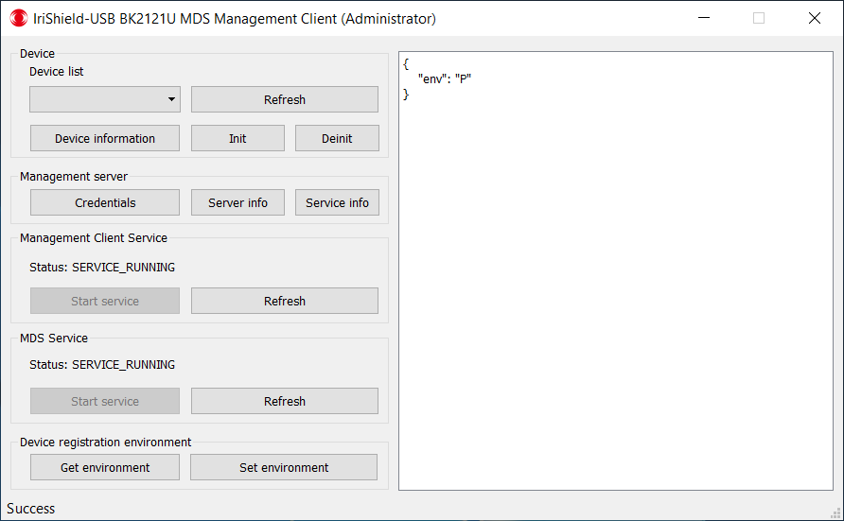

* To set environment by clicking on “Set environment” button, the list of registration server is shown. Choose the environment and click “OK” button. Please notes that the environment PP, S and D only used for developer to test.

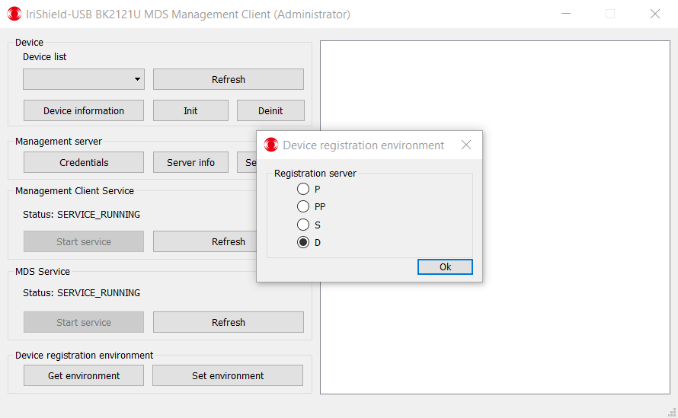

* Click on “Get environment” button to check the environment which was setting before.

## Management Service Settings

Open IriShield-USB BK2121U Management Service Setting program to configure settings for management service, such as: proxy settings.

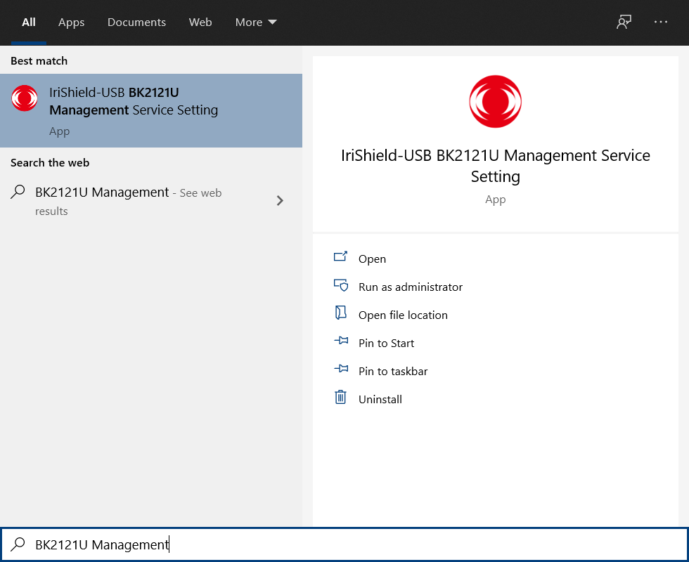

Device registration environment default as P (Production), PP, S and D only are used for developer to test. Other settings:

* Distributor name: name of distributor where you buy IriShield.
* End customer name: your name

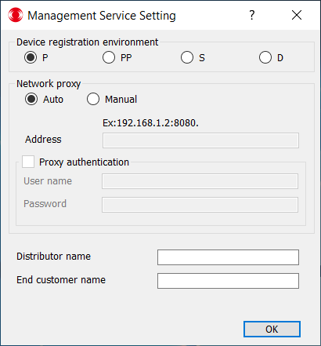

If you are not using network proxy, set the network proxy configuration as default. If you use network proxy, input the proxy configuration.

After changing settings, it is required to restart IriShield-USB-BK2121U_MDS_ClientMgmtService.

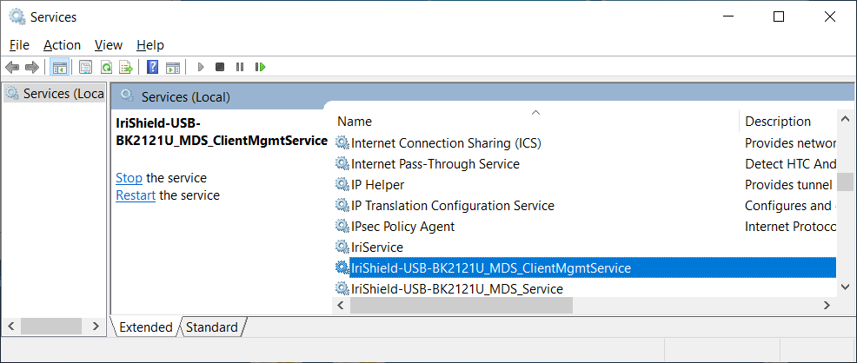

## Customer Services

If user has any concerns about this product, or need to contact IriTech for any reasons, please send a request to us at our website <http://www.iritech.com/contact/contact-us> or via email [collaboration@iritech.com](mailto:collaboration@iritech.com)

# Software updating

## Update period

* The IriShield Client Management Service is also checking for software updating when initialize device. If there are new versions that support plugged device available at server, this service will download the latest version and start software update process in the next time host computer start up.

## Update process

* If new software version was downloaded, in the next time computer start up, the update process will start. The updating process will require to uninstall the old software package and the installation wizard will be started, following the installation guideline from part **2.2. IriShield MDS Package Installation**to finish installing new software package.

# Troubleshooting and FAQ

## Windows does not recognize the device



**I plugged device and clicked refresh button in “Device”, but there is no device in device lists.**

First, kindly check wire connection between device and host.

Second, check if the device driver is installed properly. If not, please reinstall it.



## Device Busy message

**Why does IriShield Client Management Windows show** **“DEVICE_BUSY” message or ”available = false”?**



The Management Client or other services could access device to do some task such as automatically initialize, at that time device will be busy and you can’t access it using IriShield Client Management Windows. Or there is other application which is using IriShield, please check and turn off that application.



## Server communication error

**Why did I receive “SERVER_COMMUNICATION_ERROR”?**



First, kindly check your internet connection.

If internet connection is OK, please contact us via website <http://www.iritech.com/contact/contact-us> to get support



## Error Invalid serial number

**Why did I receive ‘Invalid device serial number’ when press on button ‘Init’?**



Please contact us via website <http://www.iritech.com/contact/contact-us> to get support



CONTACT US

**Headquarter Office**

3951 Pender Dr., Suite 120A, Fairfax, VA 22030, U.S.A

Tel. +1.703.877.2135 Fax. +1.703.877.2136

**Asia Pacific Regional Office**

Suite 702, KyungDong Bldg., 1659-5,

Bongcheon-Dong, Gwanak-Gu, Seoul 151-382, Korea

Tel. +82.2.872.3812

**Copyright©2020 IriTech, Inc**

www.iritech.com |

info@iritech.com |

sales@iritech.com